 | EUROPEAN COMMISSION  DIRECTORATE-GENERAL  INFORMATICS  Information Systems Directorate

European Commission
CIPADMIN Use Case Specification:
UC111 - Consult CIPAdmin Logs

Date: | 26/01/201718/09/2014
Version: | 20.000001
Authors: | Anamaria BATRINU
Revised by: | Sandro D'ORAZIO, Olivier DERVEAU, Maarten DANIELS
Approved by:
Public:
Reference Number:
TABLE OF CONTENTS
1. Use-Case Description 5
1.1. Primary Actor 5
1.2. Definitions, Acronyms and Abbreviations 5
1.3. Functional features list 5
1.4. References 5
1.5. Context Diagram 6
1.5.1. CIPA Administration Console 6
1.5.2. Verify Logs module 6
2. Flow of events 7
2.1. Basic Flow 7
2.1.1. User wants to view CIPAdmin Logs or eTrustEx Logs 7
2.1.2. Include "UC 0100 – eTrustEx Admin Console – Authenticate and Authorise User.doc" 7
2.1.3. System displays the corresponding logs page 7
2.1.4. User defines the filter 8
2.1.5. User applies the filter 8
2.1.6. System executes subflow S1- Filter Logs 8
2.1.7. User visualizes the list of logs 8
2.1.8. Use case ends. 8
2.2. Alternate flows 8
2.2.1. A1. At step 2.1.6, User wants to see details of a log record 8
2.2.2. A2: at step 2.1.6, User wants to apply a new filter 8
2.2.3. A3: at step 2.1.6, User wants to refresh the logs 8
2.3. Subflows 9
2.3.1. S1: Filter logs 9
2.4. Exceptional Flows 9
2.4.1. E1: at any step, a technical error occurs 9
3. Special Requirements 10
3.1. Interface(s) with other Systems 10
3.2. Security Requirements 10
3.3. Other Special Requirement 10
4. Preconditions 10
5. Post conditions 10
6. Additional Information 10
6.1. Includes 10
6.2. Extends 10
7. Mock-up screens 10
7.1. CIPAdmin Logs page 10
7.2. CIPAdmin Log Details page/popup 12
7.3. eTrustEx Logs Page 13
7.4. eTrustEx Log Details page/popup 15

Document History

Version | Date | Comment | Modified Pages
0.001 | 18/09/2014 | First draft | All
0.002 | 12/12/2014 | Updated diagrams and linked to user access rights mapping for BR01
1.000 | 26/01/2015 | CIPADMIN-264
1.010 | 14/10/2016 | JIRA ETRUSTEX-1664 | Sections 7.1 CIPAdmin Logs page and 7.3 eTrustEx Logs Page
1.011 | 26/10/2016 | JIRA ETRUSTEX-1392
1.012 | 09/11/2016 | JIRA ETRUSTEX-1843
2.000 | 26/01/2017 | ETRUSTEX-1937: Reorganizing CIPAdmin user roles

Use-Case Description
This use case describes how a user can consult the CIPAdmin or eTrustEx logs and what information is availbale to him/her.
In the remainder of the document the CIPADMIN application will be referred to as the System.

Primary Actor
A humain user can access the Consult Log feature via CIPAdmin interface. For detailed user access rights on each feature option, please see UC 0100 - eTrustEx Admin Console - Authenticate and Authorise User, section 6.3 User Access Rights.
In the remainder of the document, the user will be reffered to as User or by his/her role, in those cases where role specific rules apply.

Definitions, Acronyms and Abbreviations
Acronym, Abbreviation or Definition | Explanation
CIPA | Common Infrastructure for Public Administrations
CIPADMIN | CIPA AdminConsole
ADM | A user having General Administrator role. The General Administrator is the Administrator of the CIPAdmin application.
CBO | A user having Central Business Owner role. The Central Business Owner is responsible for the organization and operation of a business domain and uses CIPA in his business context.
UC(s) | Use Case(s)
N/A | Not Applicable

Functional features list
Please refer to the CIPADMIN Vision document [R1]
Release | Feature number | Feature description
1.1.0

References
Ref. | Reference | Title / description | Version | Date
[R1]

Context Diagram

CIPA Administration Console
The diagram below depicts all the Services available on the CIPA Administration Console for e-TrustEx platform. Depending on the user role, only a subset of those services is exposed on the e-TrustEx Administration Console home page.
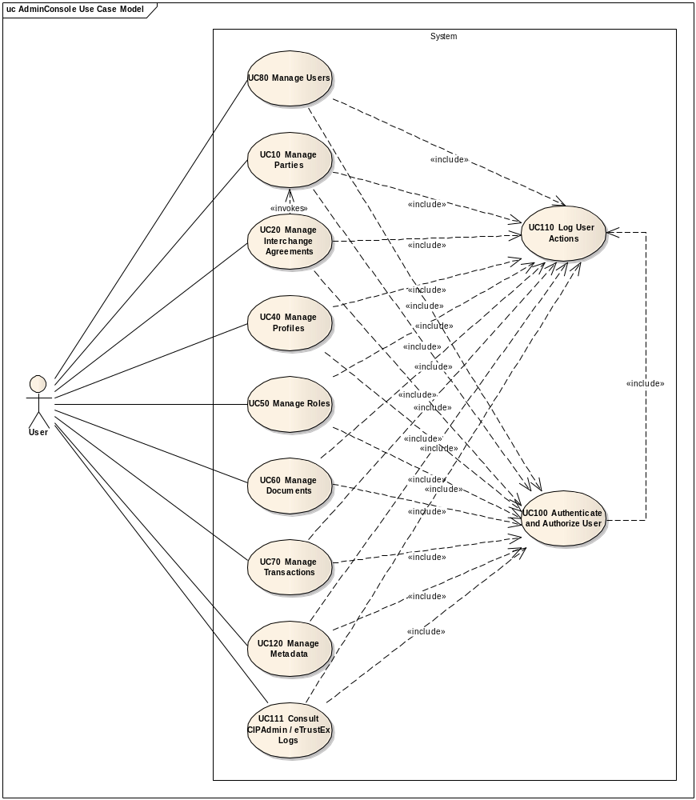

Verify Logs module
The diagram below depicts how this use case interacts with other use cases implemented in the Administration Console.
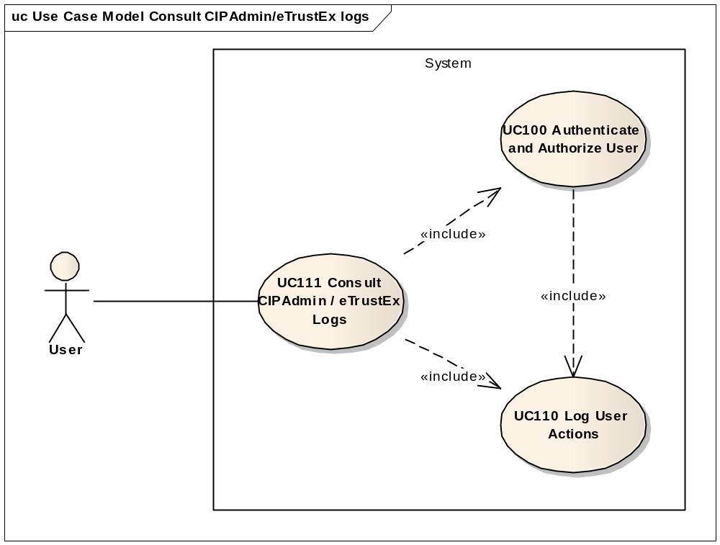

Flow of events
ID | Description
UC111_BR01 | User needs to have the correct access rights in order to access this feature. Please see UC 0100 - eTrustEx Admin Console - Authenticate and Authorise User, section 6.3 User Access Rights for more information.

The conventions described in User Interface Generic Conventions document must be applied.

Basic Flow

User wants to view CIPAdmin Logs or eTrustEx Logs
Depending on which logs user wants to see, he/she selects the CIPAdmin Logs or eTrustEx Logs option of the Monitoring and Support menu of the e-TrustEx Administration Console, or enters the page address directly in the web browser.

Include "UC 0100 – eTrustEx Admin Console – Authenticate and Authorise User.doc"

System displays the corresponding logs page
- If user choses CIPAdmin Logs, the System displays the 'View CIPAdmin Logs' page as described in paragraph 7.1. "View CIPAdmin Logs" page.
- If user choses eTrustEx Logs, the System displays the 'View eTrustEx Logs' page as described in paragraph 7.3. "View eTrustEx Logs" page.

User defines the filter

User applies the filter

System executes subflow S1- Filter Logs

User visualizes the list of logs

Use case ends.

Alternate flows

A1. At step 2.1.6, User wants to see details of a log record
- User selects the log record he/she wants to consult by clicking on it
- System opens a window containing the detailed information
- as described in paragraph 7.2. "CIPAdmin Log Details", if coming from CIPAdmin Logs
- as described in paragraph 7.2. "Log Details", if coming from CIPAdmin Logs
- User inspects the log details
- User chooses to go back to the log list
- System closes the window
- Alternate flow ends and basic flow continues from 2.1.6

A2: at step 2.1.6, User wants to apply a new filter
- User defines the new filter:
  - User clears the current filter fields
  - User fills in one or more filter fields
- Alternate flow ends and basic flow continues from 2.1.4.

A3: at step 2.1.6, User wants to refresh the logs
- User reapplies the current filter
- Alternate flow ends and basic flow restarts at 2.1.5.
Note: Logs are not automatically refreshed by the System. User shall manually reapply the filter in order to obtain the latest logs.

Subflows

S1: Filter logs
ID | Description | CIPAdmin Logs | eTrustEx Logs
UC111_BR02 | A field left empty or containing only spaces shall not be considered when the filter is applied. | X | X
UC111_BR03 | Character case is ignored. | X | X
UC111_BR04 | Trailing and leading spaces are ignored. | X | X
UC111_BR05 | Field value can contain a partial match. | X | X
UC111_BR06 | At least one field shall be filled in. | X | X
UC111_BR07 | Module "CIPADMIN" shall be used. | X | -
UC111_BR08 | Module shall be different than "CIPADMIN". | - | X
UC111_BR09 | When used for filtering, username and user session id shall contain at least 2 characters. | X | -
UC111_BR10 | When used for filtering, document type code, correlation id and business correlation id shall contain at least 2 characters. | - | X

- System applies the business rules and searches for logs satisfying all entered criteria
- System displays the logs found. If no log is found, a corresponding message shall be shown to the user (eg. "No logs found matching the current filter")
- Subflow ends

Exceptional Flows

E1: at any step, a technical error occurs
- Include UC 0110 – eTrustEx Admin Console – Log CIPAdmin User Actions for unsuccessful Access operation
- System displays a Technical Error containing an error message and the log correlation id from step (1), and also the CIPAdmin email contact to use for further assistance:
"A technical error has occured. If error persists, please contact our CIPAdmin support team at DIGIT-CIPA-SUPPORT@ec.europa.eu and provide all relevant information, including the following correlation id: correlation_id_from_previous_step"
- Corresponding flow ends.
Note: This flow shall be extracted in another use case or document as it is common to all technical errors in the application.Maybe all errors shall be gathered under an Errors Management document and be referenced from within the other use cases.

Special Requirements

Interface(s) with other Systems

Security Requirements

Other Special Requirement

Preconditions
- User must be registered user of CIPAdmin tool
- User must be logged in & successfully authenticated on the e-TrustEx Admin Console

Post conditions
- [Success] The Logs have been successfully inspected.
- [Failure] The use case is aborted and the primary actor has been notified of the reasons.

Additional Information

Includes
- UC 0100 – eTrustEx Admin Console – Authenticate and Authorise User
- UC 0110 – eTrustEx Admin Console – Log CIPAdmin User Actions

Extends

Mock-up screens

CIPAdmin Logs page
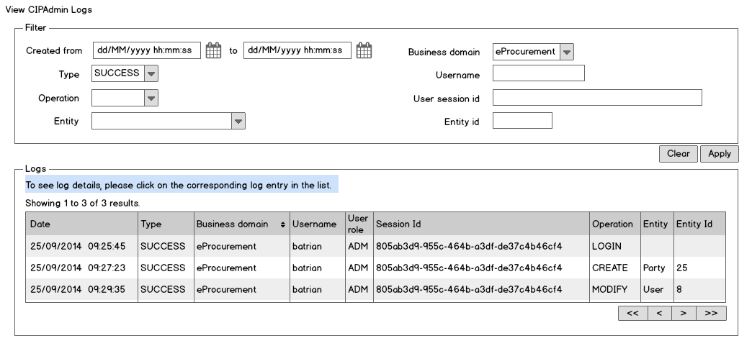
- The following filtering fields are shown on the page:
    - Start and end date and time for the log creation date; if the time is not selected when date is, the time is defaulted to 00:00:00 by the system
    - Log type and log operation
    - (as per UC 0110 - eTrustEx Admin Console - Log CIPAdmin User Actions)
    - Business domain: a list containing the business domain for which User is configured
    - Username
    - User session id (which is used to correlate the logs)
    - Entity name: a list with the entities managed by CIPAdmin (Party, InterchangeAgreement, Document, Role, User, Log etc.). The subentities manged inside one of the above entities are not subject to logging.
    - Entity id (the id of the entity concerned)
- The lists corresponding to the business domain, log type, operation and entity filters shall be ordered ascendant in alphabetical order and ignoring case
- The following buttons are present under the Filter section:
    - A Clear button for clearing or reinitializing all filter fields
    - An Apply button for applying the current filter
- The list of log records is empty when the page is first accessed, and shall be filled in when the user chooses to apply a filter.
- The results shall be ordered in descendant order by creation date and contain the following information:
    - Creation date and time
    - Log type
    - Business domain
    - Username
    - User role
    - User session id
    - User operation
    - Entity concerned
    - Id of the entity concerned
- Navigation buttons shall be present, ensuring user navigation to the next or previous pages in the list, as well as to the first and last page. Pagination shall also be used with a limit of 50 logs per page.
- Caption shall be used to indicate where in the result list the user is positioned (eg. "Showing 51 to 100 of 123 results")

CIPAdmin Log Details page/popup
- All fields present on the page are read-only.
- Cancel button is present on the screen, allowing the user to go back to the result list, at the same page from where the Log Detail has been opened.
Figure 1. Success Log Detail
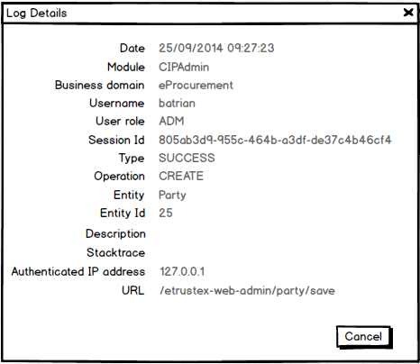

Figure 2. Error/Exception Log Detail
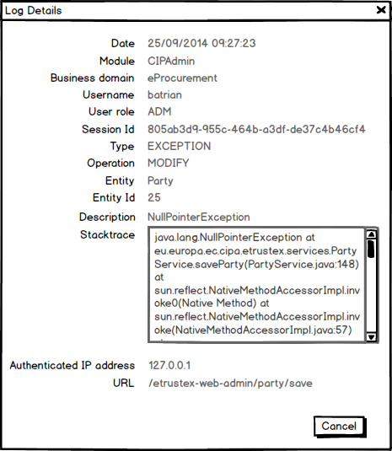

eTrustEx Logs Page
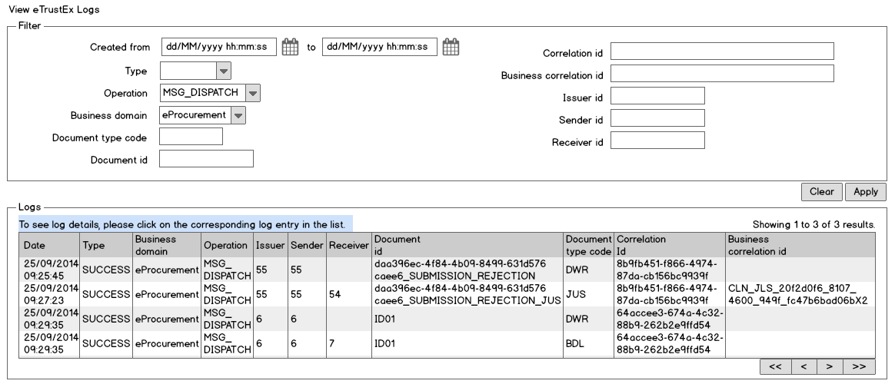
- The following filtering fields are shown on the page:
    - Start and end date and time for the log creation date; if the time is not selected when date is, the time is defaulted to 00:00:00 by the system
    - Log type: a list containing possible log type values
    - Log operation: a list containing possible operation values
    - Business domain: a list containing the business domain for which User is configured
    - Document type code
    - Document id
    - Log correlation id (which is used to correlate the logs)
    - Business correlation id (used to further correlate specific processing)
    - Issuer id
    - Sender id
    - Receiver id
- The lists corresponding to the business domain, log type, operation and entity filters shall be ordered ascendant in alphabetical order and ignoring case
- Same as point (3) from section 7.1. CIPAdmin Logs page
- Same as point (4) from section 7.1. CIPAdmin Logs page
- The results shall be ordered in descendant order by creation date and contain the following information:
    - Creation date and time
    - Log type
    - Business domain
    - Operation
    - Issuer id
    - Sender id
    - Receiver id
    - Document id
    - Document type code
    - Correlation id
    - Business correlation id
- Same as point (5) from section 7.1. CIPAdmin Logs page
- Same as point (6) from section 7.1. CIPAdmin Logs page

eTrustEx Log Details page/popup
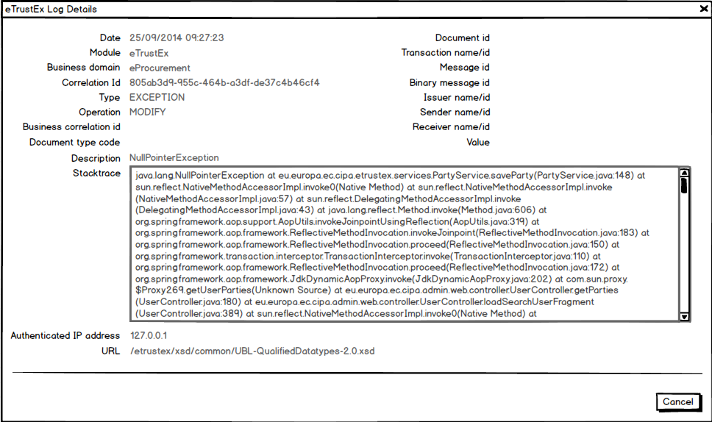
The following log fields are shown on the page:
- The creation date
- The module: as the module field is new, might be that it does not contain data for eTrustEx, case in which the value shall be defaulted to "eTrustEx"
- Business domain name
- Log correlation id
- Log type
- Operation for which the log was created
- The business correlation id
- The document type code
- The document id
- The transaction name corresponding to the transaction id, if it exists, the transaction id otherwise
- The id of the message
- The id of the binary message
- The issuer name corresponding to the issuer id, if it exists, the issuer id otherwise
- The sender name corresponding to the sender id, if it exists, the sender id otherwise
- The receiver name corresponding to the receiver id, if it exists, the receiver id otherwise
- The log value
- Log description
- Log stacktrace
- Authenticated IP address
- Accessed URL

